CommonTime Cadenza Installation Guide

Trademark Acknowledgement 1
Software License Agreement 2
PC Installation 3
If you already have a version of Cadenza installed 3
Make sure that Cadenza is not running 3
Uninstall Cadenza 3
Preserve existing Control Database entries. 3
Copying the Control Database 3
Deleting the Control Database 4
Installing Cadenza on your PC 4
Installing the Software 4
Starting the server 16
Cadenza as a service on Windows NT 16
Cadenza installed as an Application 16
Stopping the Server 18
Cadenza as a service on Windows NT 18
Cadenza installed as an Application 18
Server Troubleshooting 19
No Application Logs 19
Application Logs 20
Sending Support Requests to CommonTime. 26
The Control Database 27
Overview 27
The Administration Role 27
Adding the Control Database to your Notes workspace. 27
Entering the Authority Key 28
Profiles 29
Adding New Users 29
Viewing and Managing Profiles 30
Fields and Formulae 33
Overview 33
Creating and editing Formula Documents 34
Logs 35
Packages and Books 37
Installing Windows CE Clients 38
PC Installation Procedure 38
Choosing which Cadenza Client to Install. 38
Windows CE Installation Procedure 40
Remote Connections 43
Getting Cadenza ready for Remote Connections 43
Configuring a TCP/IP connection 43
Setting the Cadenza Server operational Mode 44
Configuring the Remote Access Server 45
Configuring DUN 45
Configuring NT RAS 46
Configuring Windows CE for remote connections 48
Configuring Newton for remote connections 50

Trademark Acknowledgement

Cadenza, Cadenza Solo, Cadenza Concerto, Cadenza Forte and CommonTime are trademarks of CommonTime Limited. All other trademarks are acknowledged as the property of their respective owners.

Software License Agreement
YOU SHOULD CAREFULLY READ THE FOLLOWING TERMS AND CONDITIONS BEFORE USING THIS PRODUCT. IF YOU DO NOT AGREE TO THE TERMS AND CONDITIONS OF THIS AGREEMENT, DO NOT USE THE SOFTWARE. USING ANY PART OF THE SOFTWARE INDICATES THAT YOU ACCEPT THESE TERMS.
- USE
You must acquire one copy of the Software for each computer on which the software will be installed.
- RESTRICTIONS
You may not alter, merge, modify or adapt the Software in any way including reverse engineering, disassembling or decompiling. You may not loan, rent, lease or license the Software to any copy. However, you may transfer the Software on a permanent basis provided you transfer the Software, this Software Agreement and all documentation and media and you do not retain any copies. Any transfer of the Software must include the most recent update and all prior versions. If the Software is demonstration and evaluation (“D&E”) software, you my not transfer the Software for commercial purposes.
- INTELLECTUAL PROPERTY RIGHTS
All intellectual property rights in the Software and User Documentation are owned by CommonTime Limited, and are protected by United States and Canadian intellectual property laws (including patent, trademark and copyright laws), other applicable intellectual property laws and international treaty provisions. CommonTime Limited retains all rights not expressly granted.
- LIMITATION OF LIABILITY
Because software is inherently complex and may not be completely free of errors, it is your responsibility to verify your work and to make backup copies, and CommonTime Limited will not be responsible for your failure to do so. In no event will CommonTime Limited be liable for indirect, special, incidental, tort, economic, cover or consequential damages arising out of the use of or inability to use CommonTime Limited products or services, including, without limitation, damages or costs relating to the loss of profits, business, goodwill, data or computer programs, even if advised of the possibility of such damages. In no case shall CommonTime Limited’s liability for money damages exceed the amount paid by you for the software out of which such claim arose. The foregoing limitations shall not apply to claims relating to death or personal injury which arise out of products deemed to be consumer goods under applicable law. Some states or provinces do not allow the exclusion or limitation of implied warranties or limitation of liability for incidental or consequential damages, so the above exclusion or limitation may not apply to you.

PC Installation

If you already have a version of Cadenza installed

If you are already running Cadenza please follow the instructions in this section, if not please skip to “Installing Cadenza on your PC”

Make sure that Cadenza is not running

Uninstall Cadenza

If you are already running Cadenza, please uninstall any previous release (by using Control Panel - Add/Remove Programs - Cadenza). See the section “Removing Cadenza from your system”.

Preserve existing Control Database entries.

Each version of Cadenza comes with a new control database. The control database will have revised document layouts and additional documents within it. Not all of the documents will be transferred to the existing control database by changing or refreshing the design of the existing control database. It is best to replace the control database entirely during the installation process. Follow the procedure below to accommodate the update of the control database.

Copying the Control Database

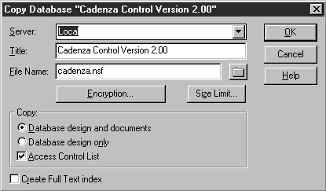
If you have changed the mapping on profiles, added additional profiles or formulae then rename the existing control database. This is most easily achieved by copying the existing control database and then deleting the original. You can just rename the file if it is not in use by Notes. Select the database by a single click. Select “File/Database/New Copy” from the Notes menu. Provide the new name and press the ‘OK’ button. Notes will copy the existing database. Now delete the database “Cadenza\cadenza.nsf”. See the procedure “Deleting the Control Database”.

Deleting the Control Database

If you have not customized your Control database in any way, then you can safely delete it. Cadenza will make a new Control database as part of the installation procedure. Use the Notes Client to delete the database. Select the database’s icon by single clicking it. Now select “File/Database/Delete” from the Notes menu. If your existing control database has multiple Profile documents, you can follow the procedure above for dealing with a customized control database.

You are now ready to proceed to installing Cadenza.

Installing Cadenza on your PC

The first thing to do is to install Cadenza on the system that will act as the Cadenza server. This system must be either Windows NT 4.0 or Windows 95 and already have installed and working a Lotus Notes Client or a Lotus Domino Server. The Lotus Notes version of the client or server must be 4.5 or greater.

Installing the Software

Starting the Installation

Make sure that you have the correct software for the Client platform you want to install. The software is available for download at www.commontime.com.

Windows CE packages are named cdzCExxx (where xxx is the version number) and Newton packages are named cdzNxxx .

Start the installation process by double clicking the icon of the downloaded package.

This will start the Cadenza Installation procedure. This is a standard InstallShield installation procedure that will prompt you for information during its execution.

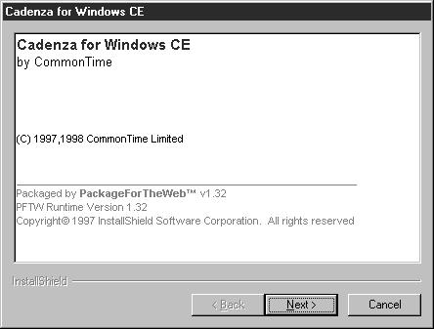
The first screen provides information about the package that you are about to install. Press the ‘Next’ button to proceed with the installation.

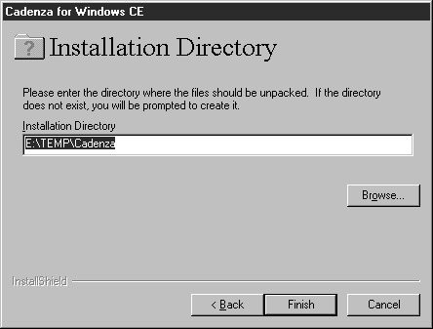
Specify a temporary location where the install procedure can expand the temporary files to. The suggested default location will usually be acceptable. Click ‘Finish’ to continue.

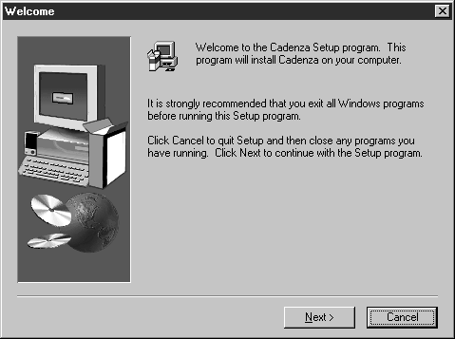
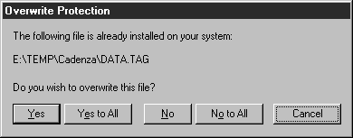
If this dialog is displayed it is because the remnants of a previous installation are still present on your system. Select ‘Yes to All’ to replace the old files with the files extracted from this installation. Having expanded all of the temporary files, the installation process will start. After a Cadenza splash screen, a series of screens will lead you through the installation procedure. Make sure that you read each of the screens carefully and provide the correct answers to any questions that are asked. Press the ‘Next’ button to continue.

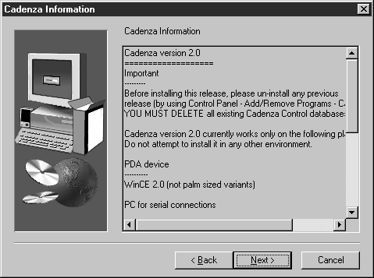
Take the time to scroll through and read the information displayed by this screen. It will contain any late breaking instructions or information that you may need during the installation process. When you’ve read the screen press the next button to continue.

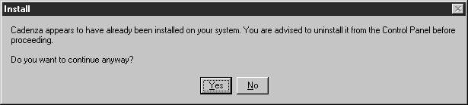
If this dialog is displayed, stop the installation, go to the control panel and run the Install/Remove software application. Remove the existing Cadenza application. Then re-run the installation procedure.

Selecting Operating Mode

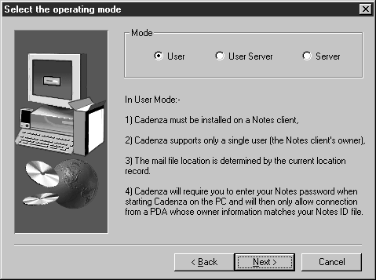
Cadenza can be installed in three different modes of operation, these are:

User

User Server

Server

The table explains each of the modes of operation of the Cadenza server.

Mode | Authentication | Multi-user | Mailfile Location
User | Name validated against the Notes Certificate Name (ID File) that the Cadenza Server is running under. | No | Specified in the currently active Notes Client location record. The fields that specify the mailfile location are:  Home/mail server  Mail file location  Mail file  Switching locations will also affect Cadenza. So that for example if you take your PC home and switch to a location that specifies a local mailfile, cadenza will also work with the local mailfile.
User Server | Each user connecting to Cadenza is authenticated using the public address book of the server named in the Home/mail server field of the current location record.  A lookup is carried out on the address book to locate a person document that matches the user.  Once the person document is located, the connecting user’s password is validated against the HTTP password in the person document. | Yes | Specified in the Person document of the designated MailServer's public address book. The Mail server is specified in the currently active Notes Client location record.
Server | Each user connecting to Cadenza is authenticated using the public address book of the server that they connect.  A lookup is carried out on the address book to locate a person document that matches the user.  Once the person document is located, the connecting user’s password is validated against the HTTP password in the person document. | Yes | Specified in the Person document of the servers public address book. The server is the machine running the Cadenza software.

When to choose User Mode

Cadenza should be installed in User Mode when you want to directly connect your personal PDA to your own desktop or laptop machine.

You will be able to interact with your own mail file and diary.

You will be able to interact with your own Personal Notes Address book and any other address books cascaded on your own machine. Any address books that are cascaded on any Notes server that is accessible from your Notes client will be available. Notes databases from your local machine and any Notes server accessible from it will also be available to the Cadenza Client.

When to use Server Mode or User Server mode

Cadenza should be configured as User Server or Server whenever you want to provide support for multiple Cadenza clients connecting to a single server. Use a User Server configuration when Cadenza is installed on a Lotus Domino Server, or when Cadenza is installed on a Notes Client machine. Each user will be able to connect to their mail file and diary. Any address books cascaded on any Notes server accessible from the machine running Cadenza will be available. Notes databases from the local machine and any Notes server accessible from it will also be available to the Cadenza Client.

You will not have access to the Personal Address book from your own desktop or laptop machine (if you have one), unless a replica of the Personal Address book is placed on a server and the user’s profile set accordingly. See the Cadenza Users Guide for details.

Setting the Server Mode

Select User to configure in User Mode, select User Server to configure in User Server Mode, select Server to configure in Server Mode. Press the ‘Next’ button to continue with the installation procedure.

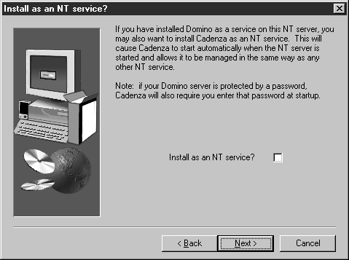
If you are installing on an NT system you will be asked if you want to install Cadenza as a service, with the following dialog box being displayed. If you check the ‘Install as an NT Service’ box, Cadenza will be installed as a service. Press ‘Next’ to continue.

Providing Notes information

Locating the Lotus Notes Software

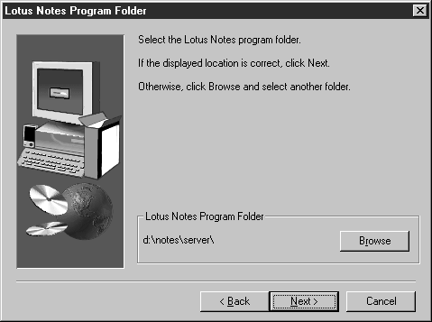
The next step involves telling Cadenza where to find the currently installed Lotus Notes software. Cadenza will read the registry of the system to determine where Notes is installed. This location will be correct if Notes was installed normally. If, however, the Notes software has been relocated, you will have to provide the correct location. Press the ‘Browse’ button to choose a ‘Lotus Notes’ software location or ‘Next’ if the location is correct.

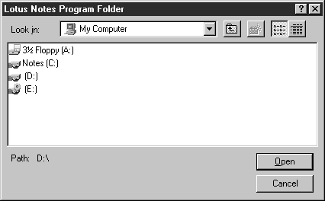
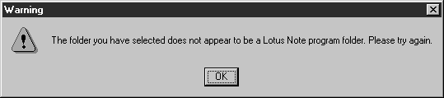
If you choose ‘Browse’ the following dialog box will appear. When you have selected the correct location press the ‘Open’ button to return to the ‘Lotus Notes Program Folder’ screen, then press the ‘Next’ button. Before moving onto the next step, the installation procedure will try to load nnotes.dll in the specified location. If this file is not present or will not load you will see this dialog box. If you see this, press OK and reselect the Notes location.

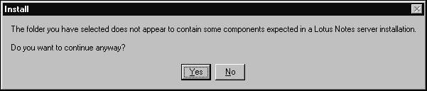
If this dialog box appears, the installation procedure is suggesting that you have selected to install in Server Operating Mode, but the currently selected Lotus Notes software location does not contain a Notes Server installation. This is determined by the presence of the file nrouter.exe. You can continue if you are sure that the correct location is selected. If you select “Server” operating mode and the installation is not a Notes Server then Cadenza will not operate correctly.

Locating the NOTES.INI file.

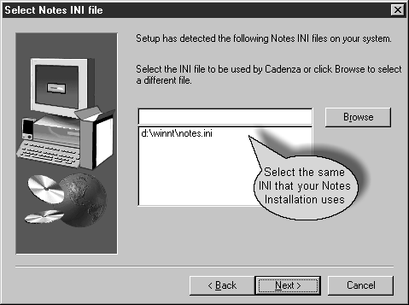
The next step is to select the NOTES.INI file that is in being used by “Lotus Notes”. The dialog box lists the available NOTES.INI files in their likely order of use. The list is built using the same search criteria that the system will use to locate INI files. Normally the first item in the list will be the correct INI file. This will not be the case if Notes runs with a specifically named INI file. Select the correct NOTES.INI file and then press ‘Next’ to continue.

Selecting or creating a Control Database

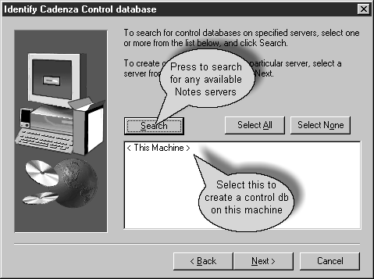
Cadenza uses the control database for a variety of purposes. These include security, customization, backup repository, and a package distribution area. Where multiple users have their own Cadenza installation, sharing a control database can simplify administration and facilitate the sharing of items such as packages and books. The dialog box shows the local machine and any servers that are available. To create a Control database on the local machine, choose the ‘< This Machine >’ entry and press ‘Next’.

Sharing a Control Database

In order to create a Control database on a server, you must have the necessary Notes privileges. Check this with your Notes administrator.

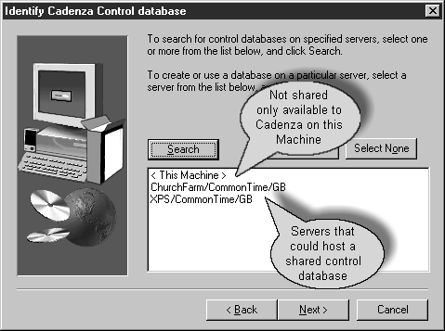
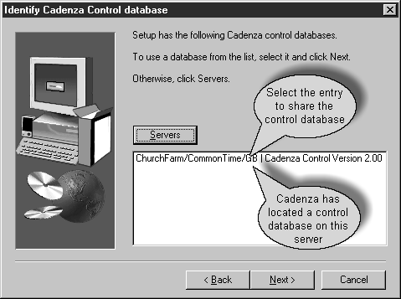
To share an existing, or create a new control database to share, on a server press the ‘Search’ button. This will display a list of available Notes servers. Select the Note server that you want to host the shared control database and then press the ‘Search’ button again. If the server has an available control database it will display as in the following dialog box. Select the Server and control database if you wish to share it. If there is not an existing Control database only the Server’s name will be displayed, select the Server to create a new control database. Select the required entry and press ‘Next’ to continue.

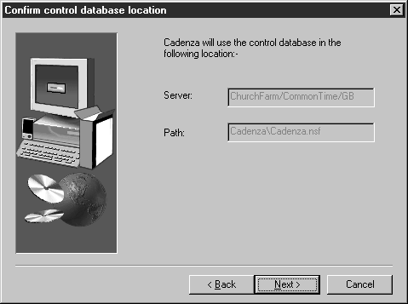

The dialog box indicates that the control database is on the server ChurchFarm/CommonTime/GB. If the server field contains ‘< This Machine >’, it means that the Notes system on the machine where Cadenza is installed will be used to host the Control database.

Creating Your User Profile

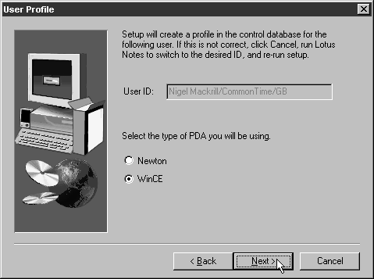
Select the type of PDA you will be using with this Cadenza installation. A User Profile for the name specified by the current Notes ID file will be created. This only happens when the Operating Mode is set to User and a new Control database is being created. In all other circumstances a profile must be created manually, see the Control Database Section. If you specify the wrong PDA type, the software will not operate correctly, however this can be easily rectified. See the Control Database section. Select the correct PDA type and press ‘Next’ to continue with the installation.

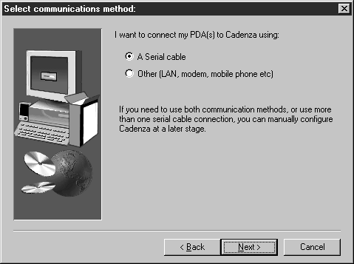
Selecting the Communications Method

Now you must specify how the client(s) will be connected to the Cadenza Server. Choosing ‘A Serial cable’ when the PDA type is Newton will make the Serial Redirector component operational. The serial redirector is not required by Windows CE installations. Though the installation procedure only allows selection of ‘A Serial cable’ or ‘Other (LAN, modem, mobile phone etc)’ you can use the Cadenza Monitor to configure both to run simultaneously.

Setting the Serial Port for the Redirector.

If you chose ‘A Serial cable’ and your PDA type is Newton you will now be asked to select the serial port(s) to be used by Cadenza. You will not be asked for a serial port if your device type is Windows CE as Windows CE Services provide the serial connection and the Cadenza serial redirector is not required. Select the port(s) that you want the server to listen for connection on. The selected ports must be available for use at the time that Cadenza starts.

Cadenza will not share ports with other applications.

Cadenza will not find any ports that are not named COM1 to COM9

You can use the Cadenza Monitor to set the port configuration if necessary. See the Cadenza Monitor Section.

Configuring the TCP/IP port

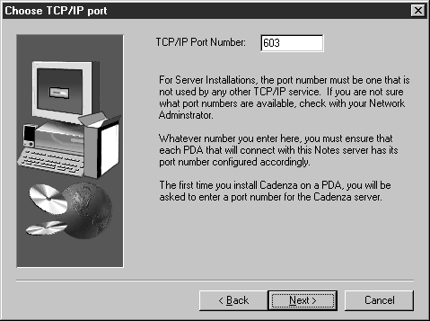
This screen allows you to set the TCP port that the Cadenza server will listen on. The specified port must be available for use. It is very unlikely that the default port 603 will be in use. If you are installing Cadenza on a Server, you should check with your Network Administrator who may allocate you a different port number.

Checking that the Port is Free

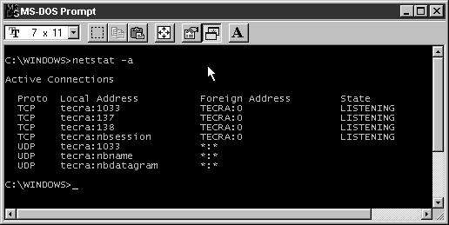
Open a new Dos Session on the PC where Cadenza is being installed. Execute the command:

netstat –a

This will list all of the ports that are currently in use. Make sure that port 603 or the port that you selected is not displayed in the local address column.

Choosing the Destination Folder and Application Group

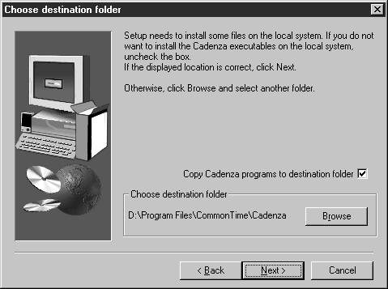
Now you must specify where the software is to be copied. Use the ‘Browse’ button to select the location where the Cadenza software will be installed.

Sharing the application

If you want to set up Cadenza as a shared application so that multiple users can share the application using networked drives then follow this procedure:

During the first installation of Cadenza use the ‘Browse’ button to select the network installation that will act as the shared software location. Check the ‘Copy Cadenza programs to destination folder’ checkbox. Now press the ‘Next’ button.

The software will now be copied into that location by the installation process. For subsequent installations use the ‘Browse’ button to select the same network location, and uncheck the Copy Cadenza programs to destination folder checkbox. Press the ‘Next’ button to continue with the installation.

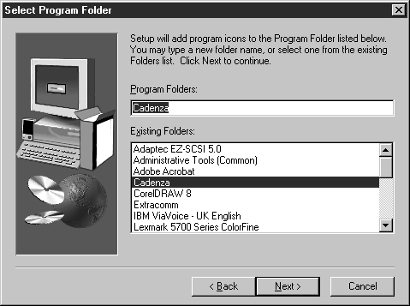
Selecting the Application Group

You will now be required to select the application group for Cadenza. Specify the name of the Application Group that you would like to contain the Cadenza Shortcuts. Press ‘Next’ to continue.

Final Steps

Cadenza will now copy the software to the selected location and configure everything as necessary.

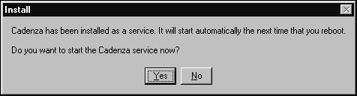
If you selected an Operational Mode of Server and elected to install Cadenza as a Service (Windows NT only), this dialog box will be displayed. Select ‘Yes’ if you want Cadenza to start now, or ‘No’ if you don’t want to start the server immediately.

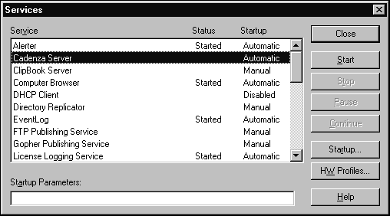
You can start the service without rebooting by going to the Service Application in Control Panel and starting the Cadenza service.

Setup Completion

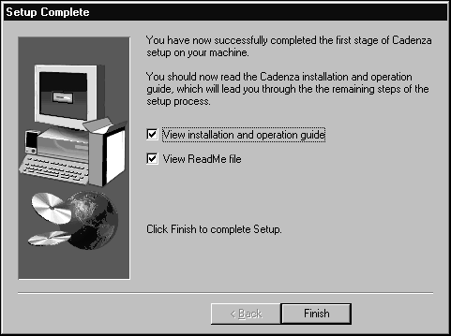
This dialog box indicates that the software installation is now complete. Please read the ReadMe file for any late breaking information. Press the ‘Finish’ button to complete the installation. Before installing any software on PDA Clients, ensure that the server is operational. See the next section 'Starting the Server'.

Starting the server

Having completed the installation of the software on the PC, the next step is to run the server for the first time, and ensure that it operates correctly.

Cadenza as a service on Windows NT

If you installed Cadenza as a Service on a Windows NT System you will not be able to use the Cadenza Monitor, though most of the information here is still applicable. Start the service from the Service Application of Control Panel. Select ‘Cadenza Server’ in the list and press the ‘Start’ button.

You can also use the NET command to start Cadenza from a batch file or Dos Window use the command:

NET START “Cadenza Server”

Enter this command exactly as displayed above.

Cadenza installed as an Application

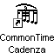
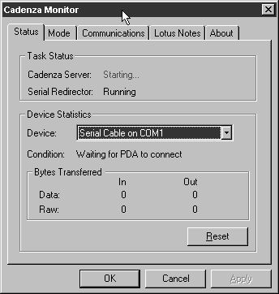
The installation procedure will have created an Icon on your desktop to run Cadenza. To start Cadenza double click this icon. You will be prompted to provide a Notes Password if the Notes ID file is password protected. The cadenza monitor screen will appear. Make sure that the Cadenza Server changes status from starting to running. If it does not do this check the procedures in the “Server Trouble Shooting” section.

For Newton serial configurations, you must also ensure that the Serial Redirector is also running.

If either the Cadenza Server or the Serial Director (if required) is not running, you must rectify the problem before continuing. Do not attempt to connect a client until these problems are resolved. See the “Server Trouble shooting” section.

Any Windows CE installation should result in Cadenza Monitor displaying with the Serial Redirector marked as <not required>. If you have a Windows CE configuration, and this is not the case then your software is not configured correctly and you should rectify the problem before proceeding.

Stopping the Server

Cadenza as a service on Windows NT

Stop the service from the Service Application of Control Panel. Select Cadenza Server in the list and press the ‘Stop’ button. You can also use the NET command to stop Cadenza from a batch file or Dos Window use the command:

NET STOP “Cadenza Server”

Enter the command exactly as displayed above.

Cadenza installed as an Application

After Cadenza has been started, if you close the Cadenza Monitor, or press the ‘OK’ button, the application will minimize and appear as an icon in the Task Bar Notification Area. This appears at the end of the Task Bar and contains a variety of Icons. To close Cadenza, right click the Cadenza Icon .

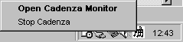
Select Stop Cadenza from the menu that appears. If you want the Cadenza Monitor to Maximize just double left click the Cadenza Icon in the Task bar Notification Area.

Server Troubleshooting

The server will shut down in a variety of circumstances, these include:

Expired Authorization Key.

No Authority document in the database.

Unable to locate the Control Database

Unable to Initialize Communication ports.

Usually looking in the Cadenza Control database at the Application Logs can solve these problems.

No Application Logs

If you open the Control Database ‘cadenza\cadenza.nsf’ and find that there are no application logs, then this usually indicates that Cadenza cannot find the control database or that you are looking at a different database to Cadenza.

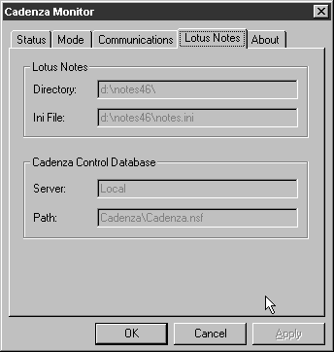
Open the Cadenza Monitor by double clicking the Icon in the system tray, or by launching it from the shortcut on the desktop. Switch to the Lotus Notes tab. This specifies where Cadenza is looking for the Control Database, in this example on the local Notes server at database ‘cadenza\cadenza.nsf’. Remember that this is relative to the designated Notes Data directory. Make sure that the database that you are examining is the same database. If this is the case run the program Cadenza.EXE (from wherever the software was installed) from a DOS window, make a note of any screens or information that is produced and place a support call to support@commontime.com reporting the circumstances and your observations.

Application Logs

This log fragment shows that the server has closed down because its authority key has expired.

Log Display

04/13/98 07:52:03 PM GDT This version of Cadenza has expired, please contact CommonTime, email: sales@commontime.com

04/13/98 07:52:03 PM GDT Cadenza will use -Local- as the server for the control database

04/13/98 07:52:03 PM GDT Cadenza will use Cadenza\Cadenza.nsf as the control database

04/13/98 07:52:03 PM GDT Cadenza will listen for connections on Port IP(P=603)

04/13/98 07:52:03 PM GDT Cadenza will listen for connections on Port HOP(F=MEM(SN=Redirector_Listen):N=MRS(P=603))

04/13/98 07:52:03 PM GDT Cadenza has opened the control database. Cadenza\Cadenza.nsf

04/13/98 07:52:10 PM GDT Cadenza will flush the Application Log and close the Control Database ...

Resolution

Resolve this problem by obtaining a Security key for the software and entering it into the Cadenza control database Authority document.

This log fragment shows a server that has no Authorization document.

Log Display

14/04/98 13:21:39 GDT Unable to locate the Authorization Note in the control database

14/04/98 13:21:39 GDT Unable to initialize the Notes system, 0 returned from NotesIni call

14/04/98 13:21:39 GDT Cadenza will flush the Application Log and close the Control Database ...

Resolution

Resolve this problem by creating an Authority document in the Cadenza control database. Having created the document remember to enter your Authorization key.

This log fragment shows a server that is unable to initialize the communications port.

Log Display

02/18/98 01:48:11 PM CST Communication Layer Error, endpoint not supported,

Cadenza will terminate

02/18/98 01:48:11 PM CST Cadenza will flush the Application Log and close

Resolution

Winsock 2.0 is partially installed on the your PC. Cadenza has located the ws2_32.dll and is attempting to use WinSock2 services. Due to the fact this is not installed correctly Cadenza fails.

This can be fixed by obtaining and fully installing WinSock2, or renaming the ws2_32.dll file in your windows/system directory.

This log fragment shows a normal start up for the Cadenza Server.

Log Display

14/04/98 13:25:00 GDT Notes will be forced to use the NOTES.INI file in location d:\notes46\notes.ini

14/04/98 13:25:00 GDT CommonTime (c) 1997, 1998, Cadenza Notes Server startup

14/04/98 13:25:00 GDT Cadenza forced into user configuration by registry settings, Only the Mail Database specified in the current Location Record will be supported.

14/04/98 13:25:01 GDT Cadenza will use -Local- as the server for the control database

14/04/98 13:25:01 GDT Cadenza will use Cadenza\Cadenza.nsf as the control database

14/04/98 13:25:01 GDT Cadenza will listen for connections on Port HOP(F=MEM(SN=Redirector_Listen):N=MRS(P=603))

14/04/98 13:25:01 GDT Cadenza has opened the control database. Cadenza\Cadenza.nsf

14/04/98 13:25:01 GDT No key present, please enter the security key that was emailed to you into the authority document.

14/04/98 13:25:01 GDT No Authority key present, Temporary 7 day key created

14/04/98 13:25:01 GDT Cadenza will stop running in 6 days

14/04/98 13:25:02 GDT Cadenza version is 1.61

14/04/98 13:25:02 GDT Notes build number is 147

14/04/98 13:25:04 GDT Loading and compiling Formula_45CleanUp

14/04/98 13:25:04 GDT Loading and compiling Formula_46CleanUp

14/04/98 13:25:04 GDT Loading and compiling Formula_AddCellPhone

14/04/98 13:25:04 GDT Loading and compiling Formula_AddChildren

14/04/98 13:25:04 GDT Loading and compiling Formula_AddCompany

14/04/98 13:25:04 GDT Loading and compiling Formula_AddDepartment

14/04/98 13:25:04 GDT Loading and compiling Formula_AddFirstName

14/04/98 13:25:04 GDT Loading and compiling Formula_AddFullName

14/04/98 13:25:04 GDT Loading and compiling Formula_AddHomeFax

14/04/98 13:25:04 GDT Loading and compiling Formula_AddHomePhone

14/04/98 13:25:04 GDT Loading and compiling Formula_AddHomePhone2

14/04/98 13:25:04 GDT Loading and compiling Formula_AddJobTitle

14/04/98 13:25:04 GDT Loading and compiling Formula_AddLastName

14/04/98 13:25:04 GDT Loading and compiling Formula_AddMiddleName

14/04/98 13:25:04 GDT Loading and compiling Formula_AddSpouse

14/04/98 13:25:04 GDT Loading and compiling Formula_AddWorkFax

14/04/98 13:25:04 GDT Loading and compiling Formula_AddWorkLocation

14/04/98 13:25:04 GDT Loading and compiling Formula_AddWorkPhone

14/04/98 13:25:04 GDT Loading and compiling Formula_AddWorkPhone2

14/04/98 13:25:04 GDT Loading and compiling Formula_Ce45CleanUp

14/04/98 13:25:04 GDT Loading and compiling Formula_Ce46CleanUp

14/04/98 13:25:05 GDT Loading and compiling Formula_CeFileAs

14/04/98 13:25:05 GDT Loading and compiling Formula_CeNamesSave

14/04/98 13:25:05 GDT Loading and compiling Formula_CleanUp

14/04/98 13:25:05 GDT Loading and compiling Formula_DisplayDate

14/04/98 13:25:05 GDT Loading and compiling Formula_FromMail

14/04/98 13:25:05 GDT Loading and compiling Formula_GetBlindCopyTo

14/04/98 13:25:05 GDT Loading and compiling Formula_GetChildren

14/04/98 13:25:05 GDT Loading and compiling Formula_GetCompany

14/04/98 13:25:05 GDT Loading and compiling Formula_GetCopyTo

14/04/98 13:25:05 GDT Loading and compiling Formula_GetDepartment

14/04/98 13:25:05 GDT Loading and compiling Formula_GetDocLength

14/04/98 13:25:05 GDT Loading and compiling Formula_GetFirstName

14/04/98 13:25:05 GDT Loading and compiling Formula_GetFirstTitle

14/04/98 13:25:05 GDT Loading and compiling Formula_GetHomeFax

14/04/98 13:25:05 GDT Loading and compiling Formula_GetHomePhone

14/04/98 13:25:05 GDT Loading and compiling Formula_GetHomePhone2

14/04/98 13:25:05 GDT Loading and compiling Formula_GetInvitees

14/04/98 13:25:05 GDT Loading and compiling Formula_GetLastName

14/04/98 13:25:05 GDT Loading and compiling Formula_GetMiddleName

14/04/98 13:25:05 GDT Loading and compiling Formula_GetNotesMail

14/04/98 13:25:05 GDT Loading and compiling Formula_GetsCreator

14/04/98 13:25:05 GDT Loading and compiling Formula_GetsCurrentOwner

14/04/98 13:25:05 GDT Loading and compiling Formula_GetSendTo

14/04/98 13:25:05 GDT Loading and compiling Formula_GetSpouse

14/04/98 13:25:05 GDT Loading and compiling Formula_GetWorkFax

14/04/98 13:25:05 GDT Loading and compiling Formula_GetWorkLocation

14/04/98 13:25:05 GDT Loading and compiling Formula_GetWorkPhone

14/04/98 13:25:05 GDT Loading and compiling Formula_GetWorkPhone2

14/04/98 13:25:05 GDT Loading and compiling Formula_Is46Company

14/04/98 13:25:05 GDT Loading and compiling Formula_Local

14/04/98 13:25:05 GDT Loading and compiling Formula_NULL

14/04/98 13:25:05 GDT Loading and compiling Formula_Remote

14/04/98 13:25:05 GDT Loading and compiling Formula_SetDuration

14/04/98 13:25:05 GDT Loading and compiling Formula_SetFullName

14/04/98 13:25:05 GDT Loading and compiling Formula_SetNewDate

14/04/98 13:25:05 GDT Loading and compiling Formula_SetNewDuration

14/04/98 13:25:05 GDT Loading and compiling Formula_SetNoticeBody

14/04/98 13:25:05 GDT Loading and compiling Formula_SetNoticeDate

14/04/98 13:25:05 GDT Loading and compiling Formula_SetResponses

14/04/98 13:25:05 GDT Loading and compiling Formula_SetStartDate

14/04/98 13:25:05 GDT Loading and compiling Formula_SetTypeAndForm

14/04/98 13:25:05 GDT Loading profile for CN=Nigel Mackrill/O=CommonTime/C=GB

Sending Support Requests to CommonTime.

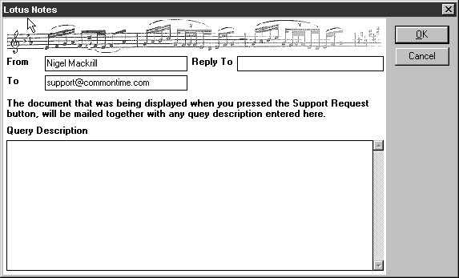
Whenever you are displaying a document in the Control Database there is a ‘Support Request’ button displayed on the Action bar of the form. Pressing this button will send an image of the displayed document to support@commontime.com allowing you to make any comments or add additional information to your requests.

The Control Database

Overview

The Cadenza control database is the administrative heart of Cadenza. In multi-user environments, administrators and users will benefit from sharing the same Cadenza control database. Instead of being distributed across large numbers of desktop machines, all the information that controls and records the operation of Cadenza will be stored in one place.

The Cadenza control database also serves as the central repository for PDA backups, application packages and other files. In this way, the administration of large numbers of PDAs is greatly simplified bringing tangible benefits to the whole organization.

The Administration Role

Creation of most of the documents in the Control database is restricted to members of the Administration role. Ensure that the ACL settings for the Control database include your entry in the Administration Role.

Adding the Control Database to your Notes workspace.

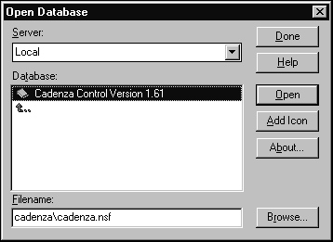
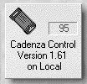
Add the control database to your Notes workspace. Run your Lotus Notes client, choose File\Database\Open from the menu. A dialog box similar to the one on the left will appear. Expand the folder Cadenza and select the Cadenza Control database. Use the ‘Open’ or ‘Add Icon’ buttons to continue. This will create a Notes database Icon on your current workspace page that looks like this. Double click this icon to open the Cadenza Control db.

Entering the Authority Key

When you download Cadenza from the CommonTime website, you will be emailed an authority key. If you purchase Cadenza you will also be sent an authority key. This key must be entered into the Authority document of the control database.

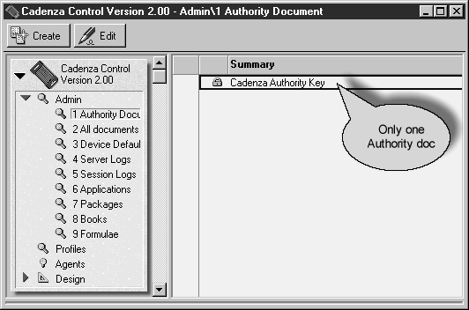
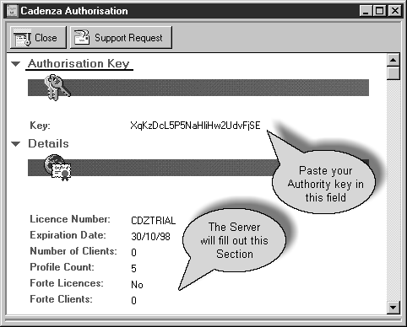
Open the Cadenza Control database. Select the view ‘Admin/Authority Document’. If the Authorization document is displayed, double click it to open. If you cannot see an authorization Key document, press the Create button, or select Create\Authority from the Notes Menu. The Cadenza Authorization form will be displayed. Enter the Cadenza Authority Key in the ‘Key’ field. It is important that the key is exact - the easiest way to achieve this is to use Edit - Copy to copy the key from its source document and Edit - Paste to paste it into the ‘Key’ field. Cadenza will not operate without a valid key. Save and Close the Cadenza Authority Key document.

Note: The Cadenza Authority Key has encoded within it the License Number, Expiration Date and the Number of Clients (users) licensed. After you have run Cadenza for the first time, the Authority Key document will display the current values of these fields. If the Profile Count (the number of user profiles in the Cadenza Control database) exceeds the Number of Clients, you are in breach of your License Agreement. Warning messages to this effect will appear in the Application Log.

Profiles

Each Cadenza user has an individual profile. This profile controls the operation of Cadenza for the one specific User.

Part of the Cadenza authentication process consists of locating a user profile for the person trying to connect. If no matching profile is located the connection will be rejected.

In order to minimize the work in supporting multiple Cadenza users, User Profiles are based on default PDA profiles. Each default PDA profile is associated with only one kind of PDA; there can be multiple defaults for a single PDA type. Should you wish to make changes for all users of a certain PDA default, edit the default document for that.

Adding New Users

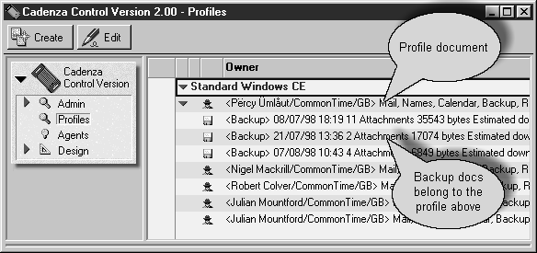
Open the Control database, and go to the view Profiles. Press the ‘Create’ button on the Notes Action bar then select Profile, or select Create/Profile from the Note menus.

Simply choose the appropriate device defaults, and the settings for are copied across into the new user profile. Further modifications can be applied to customize individual user profiles if necessary.

Viewing and Managing Profiles

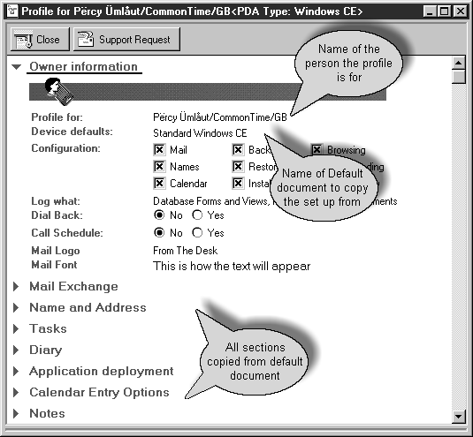
Open the Control database and select the view ‘Profiles’.

A Profile form has the following fields and sections: -

Profile for:

Enter the user's distinguished Notes name in abbreviated format, e.g. John Smith/AcmeCorp or select it from the appropriate address book.

Device defaults:

This names a default profile document to copy all of the values from. (Note: Choosing alternative Device defaults resets the whole Profile document to the default values.)

Configuration:

This allows the administrator to control the services made available to any particular user. Uncheck any boxes that are not required. Not all PDA types support all options, see the software release notes for your version of Cadenza.

Logging Level:

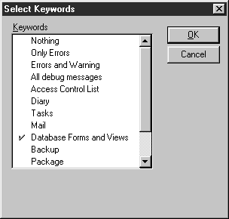
Unless this is set to ‘Nothing’, Cadenza will log information about each Cadenza session that this user performs.

If you are experiencing problems with Cadenza, select the areas that you want to collect information about. This will restrict the log entries to the areas of interest, making the process of examining the log more straightforward.

In normal operation set this to ‘Only Error’, or ‘Errors and Warning’.

Dial Back and Call Schedule:

These have no function at the moment and are reserved for future use.

Mail Logo:

Select the stationery type to be used for all Notes mail generated and sent from this user's PDA.

Mail Font:

Determines the font that will be used for all Cadenza (Lotus Notes) mail generated and sent from this user's PDA. Press Alt + Enter (or single right mouse click and select Text Properties). Highlight all of the text ‘This is how the text will appear’ and select the font to be used.

Mail Exchange:

Max mail Length:

This determines the point at which Notes mail messages will be truncated when being transferred to the PDA

NOTE: If the selected PDA type is Newton and Newton Press is installed on the Cadenza server machine, the full text of all mail items longer than the Max mail Length will be automatically converted into a Newton book. This book will be available as an attachment to the mail item and may be detached from the truncated mail message if required.

All other Mail Exchange fields:

These control how the various fields in a Lotus Notes mail item are mapped to the PDA’s mail item and vice versa. You are advised not to change any of these settings unless you are sure that you know what you are doing. Changing these may cause Cadenza Mail to malfunction.

Name and Address:

Personal Address Book Replica:

These fields specify where Cadenza can find a replica of your personal address book. You need only set this when Cadenza is running is Server or User Server mode and you want to be able to modify the Personal address book, which is part of your Notes client installation. Your Notes Administrator must make a replica of your Address book on one of the Notes servers that Cadenza can connect to.

Custom Name and Address Book:

This allows the Names Import/Export and Synchronize functions in Cadenza Connect Utilities to be extended to work with any suitable Lotus Notes database (e.g. a customer or contact management database) even if it not based on a Lotus Notes address book design.

People:

This section controls the field mapping for Person documents in all Notes Public Address Books and Notes 4.5 Personal Address Books.

Business Cards:

This section controls the field mapping for all documents in Notes 4.6 Personal Address Books.

Companies:

This section controls the field mapping for Company documents in Notes 4.5 Personal Address Books

Calendar Entry Options:

Hide new Calendar Entries from public viewing:

This sets the default behavior for a Notes Meeting.

If the supported PDA is a Newton, the meeting's ‘Notes Options’ override these defaults.

Remove Invitations from my Inbox after I respond to them:

Removes a meeting invitation message from the Lotus Notes Inbox after you have responded to it.

These two settings only affect calendar entries/responses generated on the Newton. They do not need to be the same as their counterparts in the user's Calendar Profile in Lotus Notes. In other words, the Notes Calendar profile controls what happens when entries are generated using Lotus Notes. The settings in the user's Profile in the Cadenza Control database determine what happens for entries that are generated on the Newton.

If you have made changes to the Profile, you should now Save the Profile and Close the form.

Fields and Formulae

Overview

Field mapping information is presented in profiles in 3 columns – Notes From, PDA and Notes To. As the names suggest, the Notes From column contains the field (or formula) to be mapped to the corresponding field in the PDA column when moving data from Notes to the PDA. The Notes To column defines the mapping to be used when moving data from the PDA to Lotus Notes.

Where a simple field is used in either of the Notes columns, it is specified by its name. A Lotus Notes formula can also be used. All formulas must have a name in the format “Formula_<name>” where <name> is a unique, user defined name for the formula. Please note, formula names are case sensitive.

As an example of why different field mapping is sometimes required dependent on the direction of the data transfer, consider the following: -

A Newton only stores one First Name for a person whereas Lotus Notes allows you to store many. When Importing a name from Lotus Notes to the Newton, a formula (“Formula_GetFirstName”) is used to extract the first element of the FirstName field in the Lotus Notes document. When synchronizing a name from the Newton to Lotus Notes, a different formula is used (“Formula_AddFirstName”). This formula compares the Name.First field on the Newton with the list of first names in the Lotus Notes document. Then, if Name.First name already exists in the list of first names, it is moved to the head of the list or, if it does not already exist in the list, it is added at the head of the list.

Sometimes it is not necessary to make an entry in all 3 columns. In the case of Newton phone numbers, it is necessary to map both the fields WorkPhone and Phone to the same Lotus Notes field (“OfficePhoneNumber”). This is achieved as follows: -

Notes From PDA Notes To

OfficePhoneNumber WorkPhone Formula_AddWorkPhone

Phone Formula_AddWorkPhone

IMPORTANT: Any line with an empty “Notes From” element must be at the end of the list.

Creating and editing Formula Documents

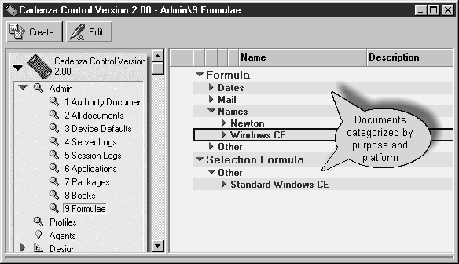
To create or edit a formula open the Control database and go to the Admin\ Formulae view. Press the Create button to make a new formula document. To open an existing document, double click the document in the view.

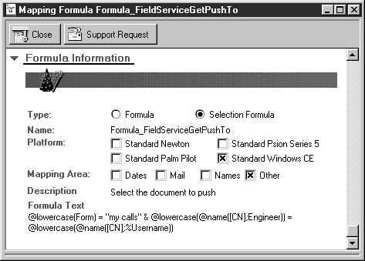
The Mapping Area checkboxes on the Formula documents categorize the formulae by the application areas in which they are intended for use. Setting them correctly will make it easier for you when amending a profile since the pop-up list of available formulae uses these categories.

Caveats
Watch out for these points | Notes
A formula must return a value. For example, if you are using a formula solely to set the contents of a field, you must append a null string to the end of the formula.  Also notice the use of CdzTempValue in this Notes To formula. For each field in the PDA column, the special field name CdzTempValue refers to the temporary storage area containing the data transmitted by the PDA from that field. | Field CellPhoneNumber := @trim(@unique(CdzTempValue:CellPhoneNumber));""
Formula_NULL is a special formula. | This is used solely as a placeholder since the NoteTo column is not allowed to be empty. It has no operational effect
$$QuerySave is a special formula | Can only be used in the PDA column. This causes the associated formula in the Notes To column to be executed after all other data for the current document has been processed. There is no corresponding entry in the Notes From column.
Formulas are compiled and loaded when the Cadenza server is started. If you have created or changed a formula, remember to stop and restart the Cadenza server. Or press the reload button on the Cadenza monitor.
When using a Custom address book, the ‘Form’ field must be defined explicitly. For example:- | Notes From | PDA | Notes To
 | Formula_GetForm | Form | Formula_SetForm

Logs

Each time the Cadenza server is started, an Server log is created. This can be very useful in troubleshooting. If submitting a Support Request to CommonTime, please include the relevant Application Log.

Each time a User Connects a Session log is created. The contents of these logs vary according to the Logging Level option of the user’s profile.

If you experience a problem using Cadenza, it will help us to help you if you can reproduce the problem after having set your Logging Level to Debug and then mail the Session log to CommonTime using the Support Request button. Log Views

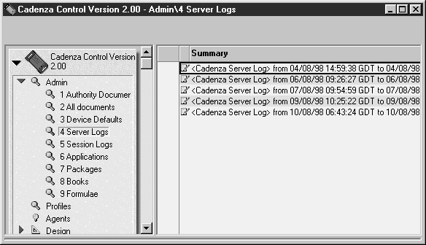
Logs can be found in the Admin view in the Cadenza control database. Choose Admin\Server Logs to review the logs created whenever the Cadenza server restarts.

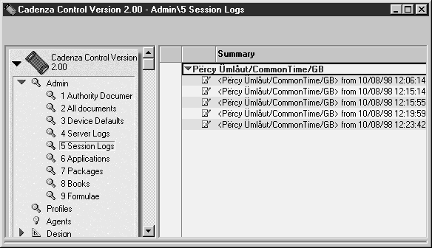
Go to Admin\Session logs to look at the logs for each user’s session.

These a categorized by user name, and sorted in date order. Each document records information from one session.
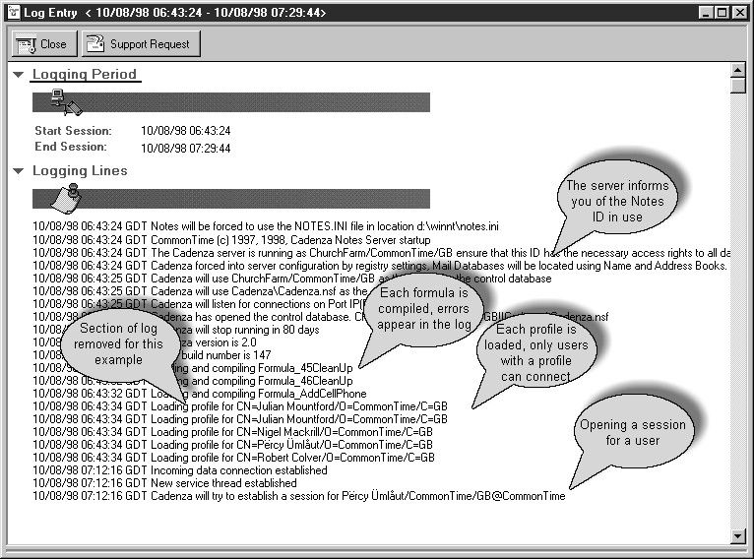

This is an example of a Server Log with some useful items highlighted.

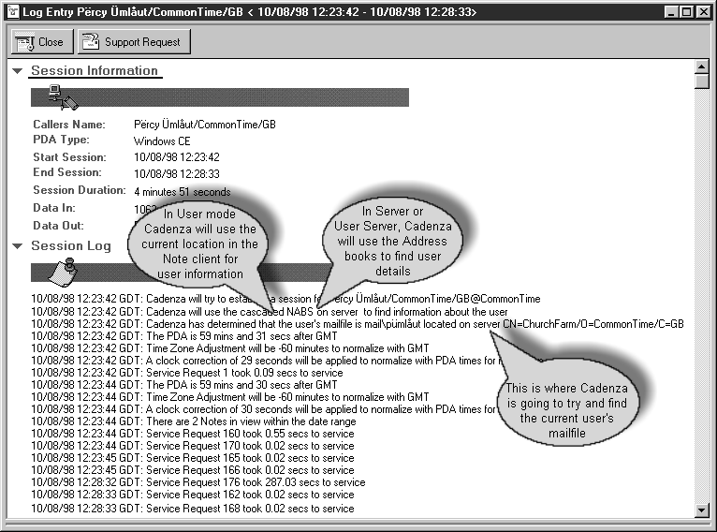
This is an example of a Session Log with some important information indicated.

These log are only written out on the completion of the session, this is usually when the PDA disconnects from the Cadenza server.

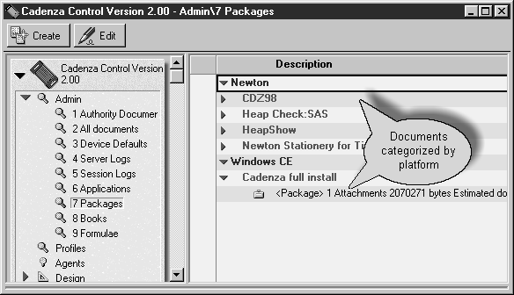
Packages and Books

Both PDA application packages (executables) and Newton books can be created and stored in the Cadenza control database. From here users can browse, select and download items. Packages will install onto the PDA at the when the Cadenza Utilities application is closed.

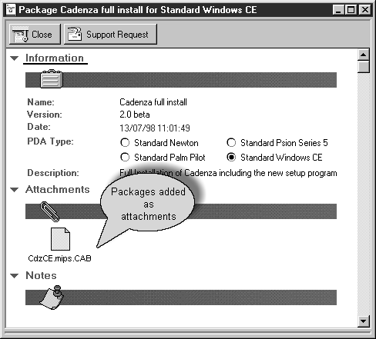
To create a new package, you must be a member of the Admin ACL role. Press the create button on the packages view. Fill out the information on the form, and attach the package items to the Attachments field. For a Windows CE device these will normally be .cab files.

Installing Windows CE Clients

During the installation procedure the following library will have been created on your PC:

Program Files/Windows CE Services/Cadenza

This library contains the client software for the Window CE device.

To install the Cadenza Client on your Windows CE device follow the following procedure.

PC Installation Procedure

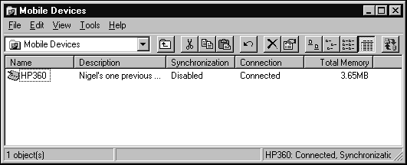
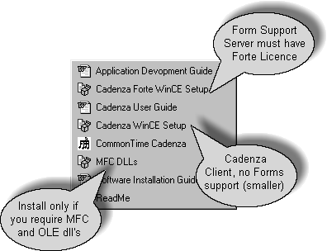
Firstly make sure that your Windows CE device is connected to your computer. Windows CE services Mobile Devices will display the connection status, as will the icon in the Task Bar Information Area. When you are sure that you have a connection to your Windows CE device, use the start button on your PC the open the required shortcut.

Choosing which Cadenza Client to Install.

Note: Only install one of the two Cadenza clients, do not install both.

Cadenza Forte.

Is larger than the normal client

Includes the Cadenza forms application.

Will only work with a licensed server.

Cadenza.

Is Smaller.

Does not include the Forms application.

Will work with any server.

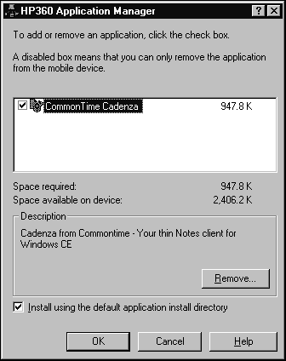
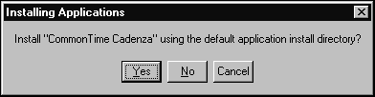
Select Cadenza Forte WinCE Setup to install Cadenza Forte or Cadenza WinCE Setup to install Cadenza. Selecting either will start the installation process. The following dialog box will be displayed, followed immediately by this dialog box.

Click “Yes” to continue with the installation process. The software will now be installed onto the Windows CE device.

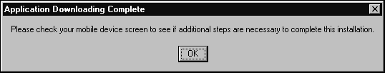
This message indicates that the installation process is ready to proceed on the Windows CE device. Check your Windows CE device and continue with the installation and configuration.

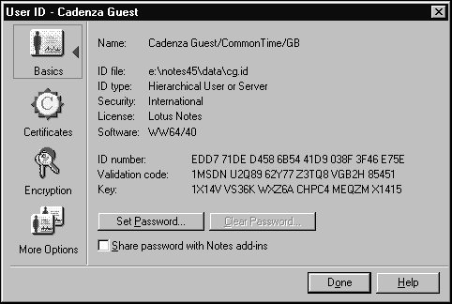
Information that is required during installation are your Notes Name, and any Internet Password set in the Notes Public Address book. To ensure that you get the Notes User name correct, run your Lotus Notes client and select File\Tools\User ID from the menu. This will display the userid information. Name displays the name that you should use to identify yourself in the Cadenza client.

Note: If you check “Share password with Notes add-ins” checkbox, on the picture above, then when the cadenza server starts it will not ask for a password if you have already started Notes and provided the password.

You cannot display your Internet Password as it is encrypted before being saved. Entering a new value will reset it. You may have to get your Notes administrator to do this for you depending on your access rights to the Public Name and Address book. If you have configured the server in User mode, the password will not be used in authentication. If the server is configured as Server or User Server then the password value must be entered correctly into the PDA or you will not be allowed access to the Lotus Notes system.

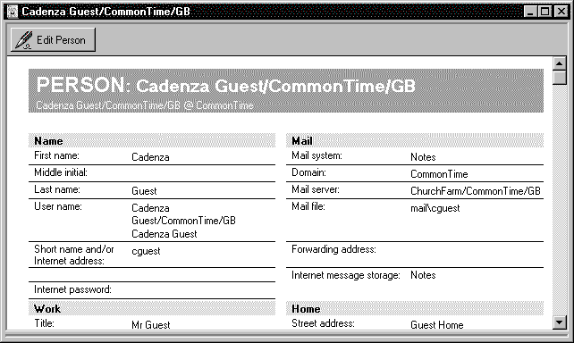
Windows CE Installation Procedure

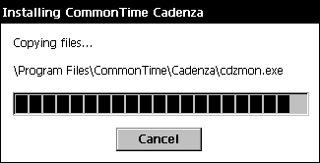
The flood bar will now indicate the progress of the software installation and will clear from the screen once the installation is complete.

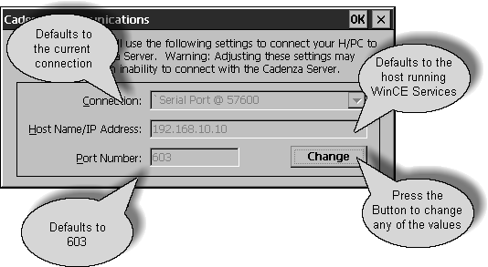
Once the software has been installed from the cab file Cadenza will automatically configure itself. You will be required to provide some information.

The installation process defaults all values in the first dialog. Only change the values if you are sure that you know what you are doing.

Connection, this will default to the currently active connection that you are using to connect with Windows CE services.

Host Name/IP Address, this will default to the IP address that WinCE services is using on the machine that you are currently connected to. This assumes that you will be running Cadenza on this machine. If this is not the case use the Change button, and set the value to the correct one. You can enter the hosts name rather than an IP address. This will work only of your PDA is able to resolve the name into an IP address.

Port, this field always defaults to 603. This MUST be the same port number that the Cadenza server is listening on. If you change this, make sure that you also change the server’s equivalent setting.

Click the change button to make changes, or OK to continue.

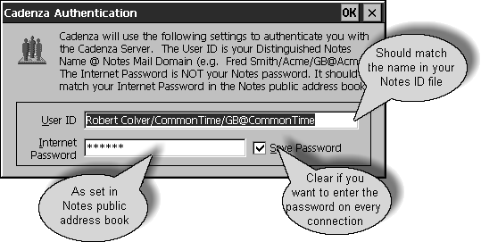
This dialog requires you to provide two items of information.

User ID, this is your distinguished Note name followed by “@” and your Notes Email domain name. The User ID must be exactly the same as displayed by your Notes certificate, including case. The domain name is not case sensitive.

Internet Password, if Cadenza is configured in Server or User Server mode, this field must contain the same value as the Internet Password field of your person document in the appropriate Notes Public Address book. If Cadenza is configured in User mode, any value may be entered, however a value must be present.

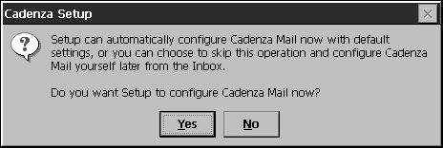
In Server mode, the Public address book used will be on the server running the Cadenza server. In User Server mode, the public address book used will be on the server named as the home/mail server in the Notes clients’ current location record. Use the menu choice “File/Mobile/Edit Current location” in the Notes client to review this value.

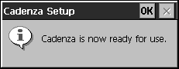
Tap the OK button to continue, you will be asked if you want Cadenza to configure your Inbox to use the Cadenza Mail transport. Select “Yes” unless you want to install the service later. A dialog will appear to inform you that the installation is complete.

Remote Connections

You can connect your PDA device to a Cadenza server by a variety of methods, these include:

Ethernet Adapters

Direct serial connection

Wired Modems

Wireless Modems

Getting Cadenza ready for Remote Connections

Wired and wireless modems enable you to connect remotely to your Cadenza server. These attachment methods depend on the networking capabilities of Windows NT and Windows 95 to provide the connection. The Cadenza server must be configured to listen on a TCP/IP port in order to work with remotely attaching devices.

Configuring a TCP/IP connection

Start or open the Cadenza Monitor on your PC. Double click the Icon on the desktop, or select Cadenza from the Start Menu or right mouse click the Cadenza icon in the Task Bar application area and then select Open Cadenza Monitor from the menu.

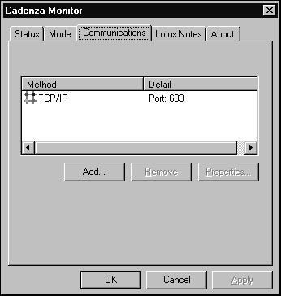
Now select the Communications tab of the Cadenza Monitor. If TCP/IP is not displayed in the list of communications methods, click the ‘Add’ button. The following dialog box will be displayed.

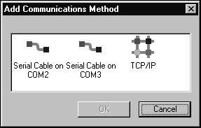
Select the TCP/IP icon from the available communications methods and then press ‘OK’. This will add TCP/IP capabilities to the Cadenza server. The TCP/IP connection will default to port 603. This port should be available for use, but you may like to check with your Network administrator. This is particularly relevant where Cadenza is running on a Notes Server. To change the port number, select the TCP/IP method in the Cadenza Monitor communications tab display, then press the ‘Properties’ button. Change the port number and then press ‘OK’.

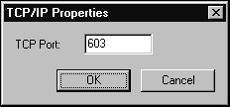
If you make any changes to the Cadenza server configuration you must stop and restart the Cadenza Server for the changes to take effect.

The Server will now be listening on the specified TCP/IP port awaiting incoming connection requests.

NOTE: The Serial Redirector component of Cadenza does not support modem connections.

Setting the Cadenza Server operational Mode

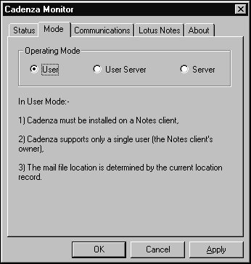
If you are the only person who will use this remote connection then Cadenza should be configured in ‘User’ mode.

If the Cadenza server is running on a Notes Client machine and multiple people are going to connect to the Cadenza server then configure Cadenza in ‘User Server’ mode.

If the Cadenza server is running on a Notes Server machine and multiple people are going to connect to the Cadenza server then configure Cadenza in ‘Server’ mode.

Start the Cadenza Monitor program, select the ‘Mode’ tab.

Select the operational mode that you require and then press the ‘OK’ button.

If you make any changes to the Cadenza server configuration you must stop and restart the Cadenza Server for the changes to take effect.

Configuring the Remote Access Server

To connect to the Cadenza server remotely, either your PC or another machine on your network must provide a Remote Access Service. There are two RAS servers provided by Microsoft.

Dial Up Networking (DUN) - This runs on a Windows 95 Machine and provides support for a single connection.

should be version 1.2 or higher. This is available from the Microsoft web site. It is also included on the Windows CE Services CD. DUN does not support IP routing, so the Cadenza Server must be running on the same machine as the DUN server.

Remote Access Server (RAS) - This runs on Windows NT Server and Windows NT Workstation. RAS support IP routing and consequently the Cadenza Server does not have to run on the same machine as the RAS server.

Configuring DUN

You can download Dial Up Networking from the Microsoft web site www.microsoft.com access the site and search for “msdun12.exe”.

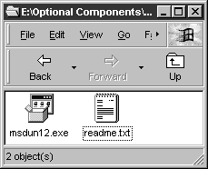
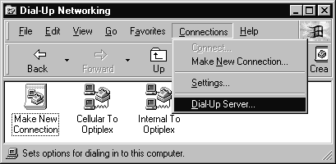
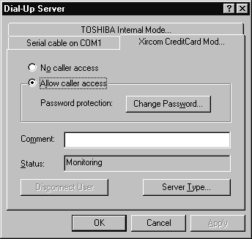
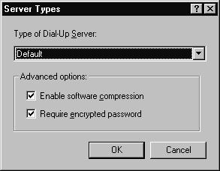
Double click the msdun12.exe Icon to install Dial-Up Networking. When the installation is complete, open the Dial-Up folder. Select Connections\Dial-Up Server from the menu. Select the tab that corresponds to the device you want to use to make the connection. Select ‘Allow caller access’. Now press ‘Server Type’. Select default or PPP: Internet, Windows NT Server, Windows 95 for Dial-Up Server type. Press ‘OK’ to continue. Press ‘Close’ on the Dial-Up Server Dialog. The server is now awaiting incoming calls.

Configuring NT RAS

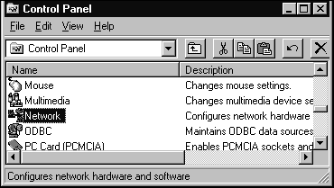
From the Control Panel select Networking. This will open the Network Properties dialog box. Select the ‘Service’ tab.

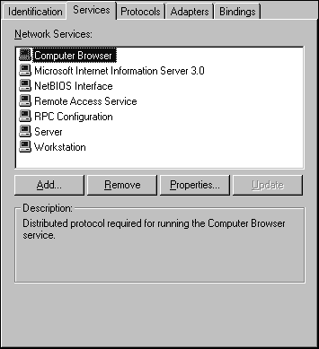
This displays a list of installed services.

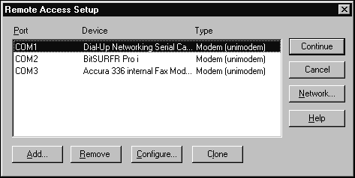
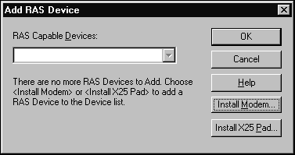
Remote Access Service should be displayed in the list of installed services. If it is not installed press the ‘Add’ button select Remote Access Service from the list of services. If you add RAS then you will be taken through the RAS configuration automatically. If RAS is already installed, select RAS in the list and then press the ‘Properties’ button.

Use the ‘Add’ button to select any devices that you want to use for RAS. The list in the combo box of the dialog will display any available devices that are not already in use by RAS. Use the ‘Install Modem’ button to add any additional modems to the system so that they can then be configured in RAS.

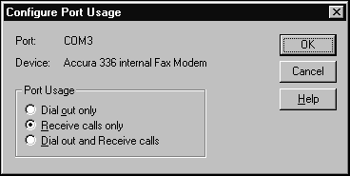
Once you have added the required devices to RAS, select the device in the Remote Access Setup dialog box and the select ‘Configure’.

You must select either ‘Receive calls only’ or ‘Dial out and Receive calls’ so that RAS will listen for incoming calls. Press ‘OK’ to continue.

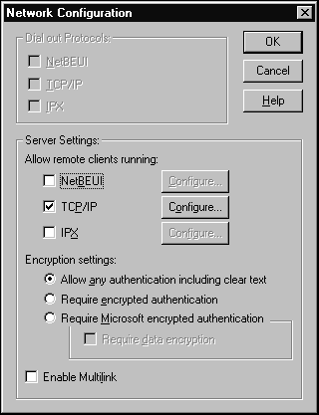
Now select ‘Network’ from the Remote Access Setup dialog box. You must include TCP/IP in the server settings.

Newton only. ‘Allow any authentication including clear text’ must be selected in order for Cadenza connections to work.

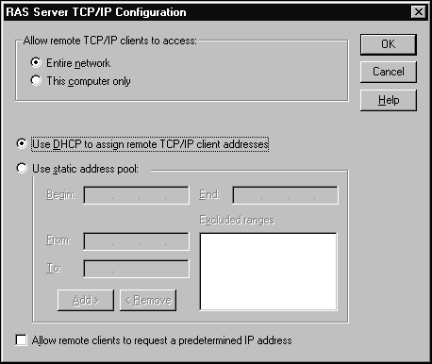
Now press the ‘Configure’ button next to the TCP/IP check box;

If you select ‘Entire Network’ then the Cadenza Server can be running on any machine on the network. If you select ‘This computer only’ then the Cadenza Server must be running on the machine that you are currently configuring.

If you are unsure of what to select for ‘Use DHCP to assign remote TCP/IP client addresses’ or ‘Use static address pool’ please seek the help of your network administrator.

Press ‘OK’ to continue. This will return you to the ‘Remote Access Setup’ dialog box, press the ‘Continue’ button to complete the installation of RAS. Press ‘Close’ on the Network dialog box if necessary.

If you added the RAS service, you need to install the latest NT Service Pack to ensure that your system has all of the latest components installed. Install the service pack after re-starting the machine.

When you have restarted the system RAS will be ready to receive calls.

Configuring Windows CE for remote connections

Setting up Remote Networking

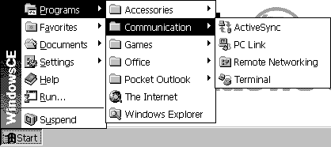

From the ‘Start’ button on the taskbar of the Windows CE device, select ‘Programs\Communication\Remote Networking’. From the displayed screen now double tap the ‘Make New Connection’ icon.This will run the ‘Make New Connection’ procedure. Fill out the screens as follows.

The first screen is Make New Connection.

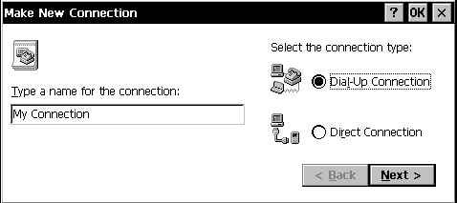
Enter and name for your connection, select ‘Dial-Up Connection’ and tap the ‘Next’ button to continue.

You will now be asked to specify which device to use for the connection.

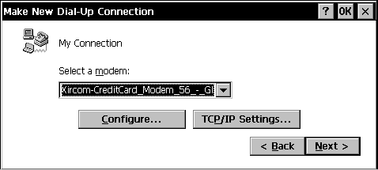
Select the modem device from the list. Tap the ‘Configure’ button if you wish to set and specifics for the modem, such as port speed etc. Tap the ‘TCP/IP Settings…’ button to continue with setting up.

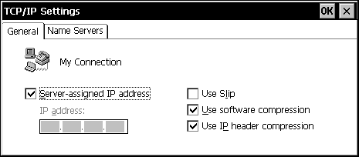
The defaults as displayed will usually work. If you want to use a specific IP address you need to ask your Network Administrator for assistance.

Tap the ‘Name Servers’ tab.

The defaults as displayed will usually work. If you want to use specific addresses you need to ask your Network Administrator for assistance.

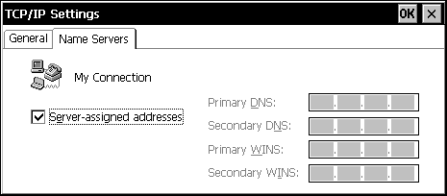
Tap ‘OK’ to return to the ‘Make New Dial-Up Connection’ dialog box, then tap the ‘Next’ button;

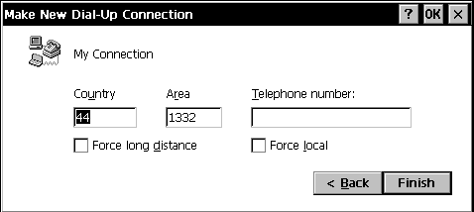
Enter the telephone number of the server that you are going to call. Then tap ‘Finish’.

You have now completed the Dial-Up connection setup. You will see an Icon that represents your newly made connection. Double tap this icon to make a dialup connection to your RAS or DUN server.

Cadenza Configuration

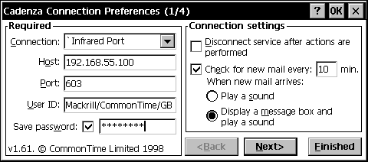
Make sure that the Host Name or IP address that you provide in Cadenza Connection Preferences is the name or address of the host machine running the Cadenza Server application. This may or may not be the same machine that you connect to.

If you are connecting to a Cadenza Server that is configured in ‘User Server’ or ‘Server’ mode, the password provided must match the Internet password in the appropriate person document in the Notes Server’s public address book.

Configuring Newton for remote connections


Setting up NIE

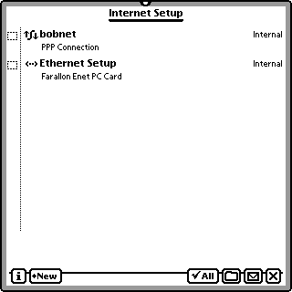
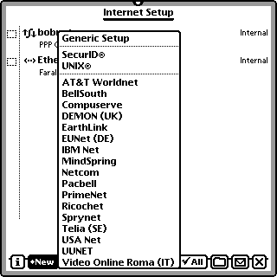
Double tap the ‘Internet Setup’ icon. This will start the NIE configuration application. This displays any existing connection configurations that are available. Tap ‘New’ and select ‘Generic’ from the list of available templates.

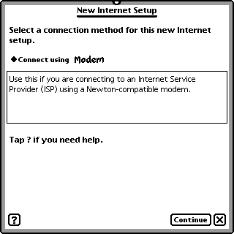
The New Internet Setup slip will be displayed.

Select the device that you want to use to make the connection, the tap the ‘Continue’ button.

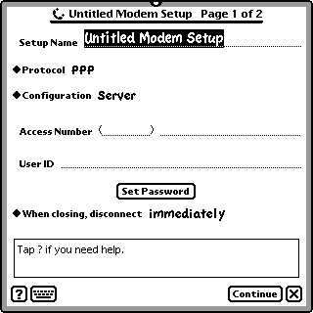
Change the Setup Name to something meaningful that describes the purpose of this connection. Leave the Protocol picker set to PPP (assuming that you will be connecting to a RAS or DUN server). Leave Configuration picker set to server. Enter the telephone number of the RAS or DUN server in the Access Number field. Set your User ID. This is the ID that you need to log on to the RAS or DUN server and not the ID that you need to log onto the Cadenza server. Tap the ‘Set Password’ button.

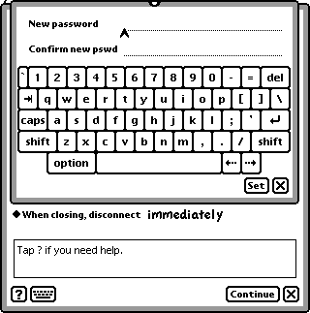
Enter the Password that you use to log onto your RAS or DUN server. This is not the Internet password used by Cadenza, but rather your Windows Networking password or your NT Domain password.

Remember to tap the ‘Set’ button.

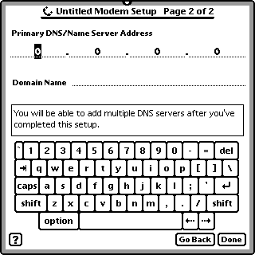

Then tap the ‘Continue’ button on the ‘Untitled Modem Setup Page 1 of 2’ slip.

Enter the IP address of your DNS server. In order for this to work the DNS server must be available from the RAS server that your are connecting to. If you are connecting to a DUN server then a DNS server will not be available.

Set the Domain Name to the Domain Name that your DNS server has authority for. If the DNS server is not available or you do not know its IP address, leave the fields set to 0.0.0.0 and the Domain Name field blank. If you are unsure of what settings to use, check with your Network Administrator.

Tap the ‘Done’ button to continue. If this slip is displayed tap the ‘OK’ button to continue.

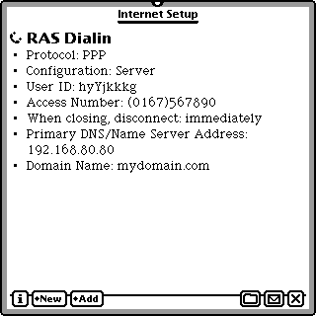
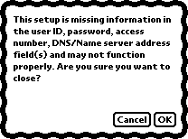
A completed Internet Setup will have the same fields filled in as the one to the right. The values will be different.

Cadenza Configuration

Check the settings in Owner Info for the Cadenza Server. If you specified a DNS server in your NIE setup you can use a host Name. If not, you must use an IP address.

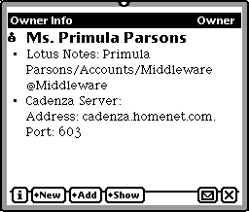
If you use a host name make sure that it is fully distinguished by including the domain name. In the examples displayed, the hostname is cadenza and the domain name is homenet.com;

You are now ready to connect to your remote Cadenza Server.

